

Student name: ISSAM AL_AWAMLEH

Student ID: 21110241

Course and sector: website design and development //2

Instructor name: HANA AL_RASHIED

Website link: <www.cyberissam.com>

**Website goal**

Who is the website for?

* automobile owners that are interested in recycling their old or used car batteries.
* environmentalists seeking environmentally friendly ways to dispose of vehicle components.
* Automotive businesses or mechanics that frequently encounter used car batteries and need a technique to properly recycle them.

What do customers/users expect to find or do there?

* Homepage: A description of the value, steps, and advantages of recycling automobile batteries.
* Registration/Login: a safe location where people may register for an account or sign in to one they already have.
* Users may enter information about their automobile batteries, such as kind, age, brand, etc., to find out whether they can be recycled and whether they have any potential worth.
* A calendar or scheduling system that allows consumers to choose a convenient day and time to drop off or pick up their batteries.
* Reservation: A feature that allows customers to obtain a consolidated view of their planned bulk disposals or bigger battery collection appointments is very helpful for workshops or those with several batteries.

Is this website’s primary aim to inform, sell (ecommerce, anyone?), or provide a service?

The website's main goal is to provide a service, namely to make it easier to recycle automobile batteries. Although there is a teaching component (informing users of the value of recycling), the primary functionality is on service delivery (battery information entering, appointments, and reservation).

**Scope**

Discerption of the scenarios:

1_Profile Creation & Management:

Situation: John, a mechanic who owns a nearby business, has gathered a number of secondhand automobile batteries over the months. He chooses to create a profile after learning about the Car Battery Recycling website. John can manage his account and keep track of his recycling activities by answering questions on the internet that ask him for pertinent information.

2_Information & Education:

Maria, a college student, is interested in how automobile batteries affect the environment. When she goes to the website, she discovers in-depth essays and infographics on the value of recycling and the damage done by inappropriate disposal.

3_Battery Info Entry & Valuation:

Situation: Lily, a car owner, wants to recycle an old battery. She signs on and enters the battery's information, including its age, kind, and brand. The system then tells her that it can be recycled and even gives her a rough idea of its potential value.

4_Scheduling Appointments:

Scenario: Lily decides to make an appointment after learning that recycling her batteries might be both beneficial to the environment and perhaps profitable. Her available drop-off times at the nearby recycling facility are displayed on the linked calendar system.

5_Appointment Overview:

Carlos, who oversees a fleet of cars, is prepared to dispose of several batteries. He utilizes the 'Appointment Overview' function to obtain a consolidated view of his scheduled battery collection schedules after arranging bulk disposal, ensuring he is ready for each pickup.

6_Feedback & Community Engagement:

Maria writes a review on her battery recycling experience after doing so successfully. She also participates in a community forum on the internet, where she picks up additional pointers on sustainable automobile practices.

The usage of the website:

When complete, the vehicle Battery Recycling website will provide both amateurs and experts looking to dispose of unwanted vehicle batteries ethically with a thorough platform. Users have the option to create and manage profiles, learn about the environmental benefits of battery recycling, assess the potential value and recyclability of their batteries, and quickly book drop-off or pickup appointments. Through participatory forums and feedback systems, the website also develops a feeling of community, which encourages more individuals to embrace sustainable behaviors.

Requirements:

User Management:

Registration: Allow new users to create an account.

Implementation: a registration form that requests a password, email address, and username. back-end verification, password hashing for storage, and sending an email confirmation for confirmation.

User Login:

Requirement: Allow registered users to log in.

Implementation: When users input their email, a password reset link or code is sent to them. They may then safely reset their password.

Profile Management:

Requirement: Users should manage their profiles.

Implementation: a user dashboard that shows user data along with edit buttons for changes. A safe database is used to store data.

Barrier Info & Recycling Process:

Battery Info Entry:

Requirement: Allow users to provide details about their car batteries.

Implementation: a form with options for uploading photos and entering battery information. backend to verify and save this information.

Recycling Process Guide:

Requirement: Educate users about the recycling process.

Implementation: a specific website outlining the procedure with infographics, videos, and text.

Appointments & Reservations:

Calendar System:

Requirement: Show available slots and let users book.

Implementation: Add a calendar plugin or a specially created system. Real-time slot availability updates via backend logic.

Automated Reminders:

Requirement: Remind users about their upcoming appointments.

Implementation: Utilizing integration with email/SMS providers, reminders may be sent based on reserved times.

Reservation Management:

Requirement: Users should cancel or reschedule reservations.

Implementation: List all bookings with edit options on the user dashboard. Calendar updates are made using backend logic.

Sitemap:

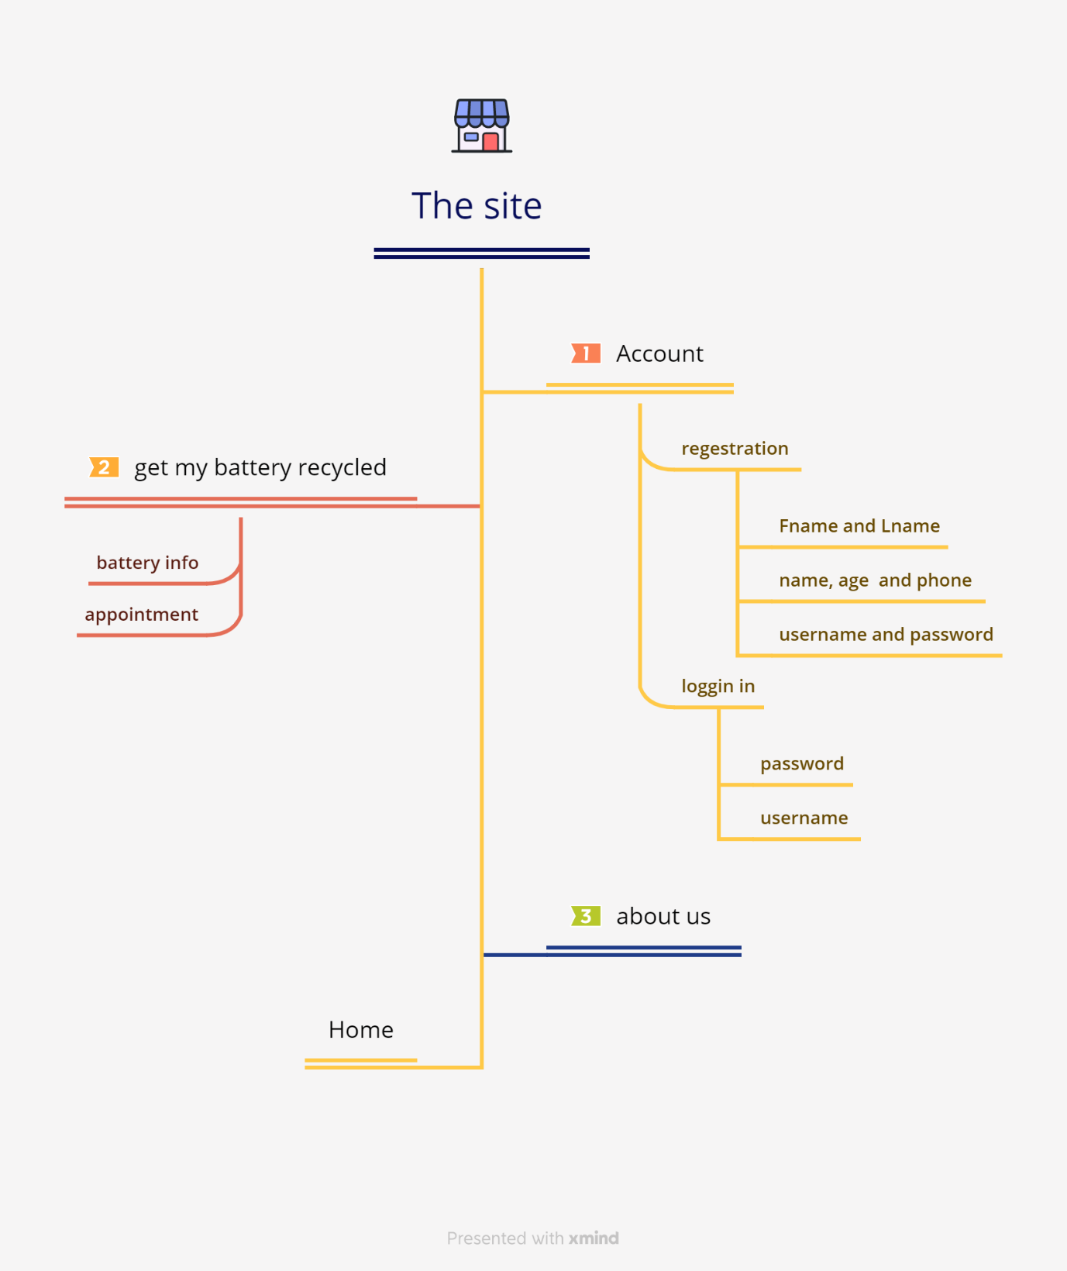

Wireframes:

Home page:

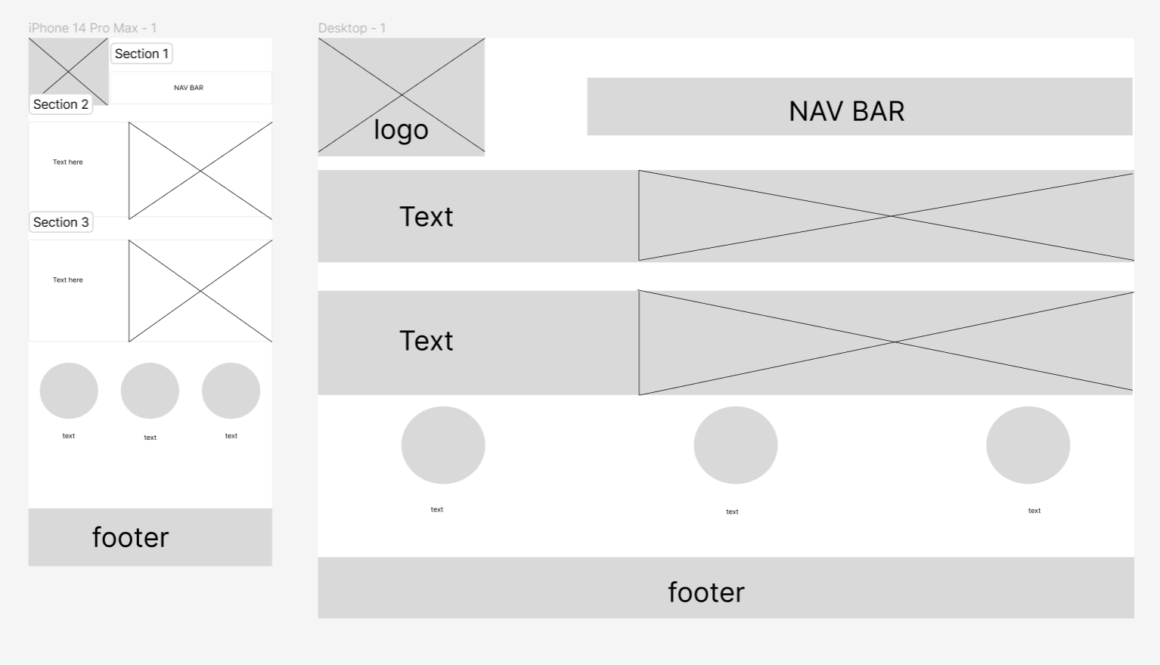

Registration and logging in:

